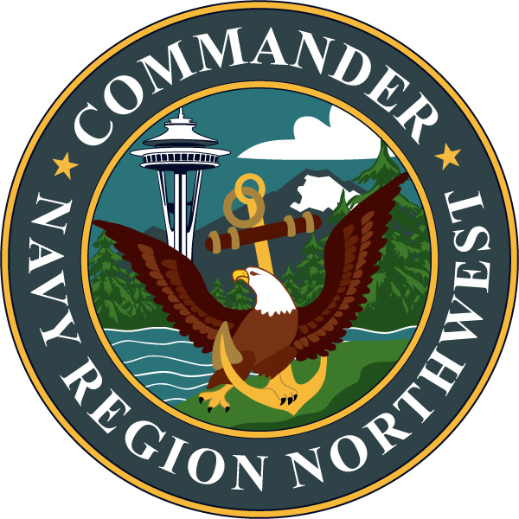
COMMANDER,

NAVY REGION NORTHWEST

Public Affairs Office

1100 Hunley Rd., Silverdale, WA 98315-1100

Phone: 360-396-1630 Fax: 360-396-7127

Aug. 22, 2017

Release # 0823417

U.S. NAVY SEEKS PUBLIC INPUT ON THE
NORTHWEST TRAINING AND TESTING SUPPLEMENTAL ENVIRONMENTAL IMPACT STATEMENT/OVERSEAS ENVIRONMENTAL IMPACT STATEMENT

SILVERDALE, Wash — The U.S. Navy is preparing a supplement to the 2015 Northwest Training and Testing (NWTT) Final Environmental Impact Statement/Overseas Environmental Impact Statement (EIS/OEIS) to assess the potential environmental effects associated with ongoing and future at-sea military readiness activities conducted within the NWTT EIS/OEIS Study Area (hereafter referred to as the “Study Area”). Military readiness activities include training and research, development, testing, and evaluation (hereafter referred to as “training and testing”). The Navy is requesting public comments on the scope of the analysis, including potential environmental issues and viable alternatives to be considered during the development of the Draft Supplemental EIS/OEIS.

The Navy previously completed an EIS/OEIS in 2015, for which a Record of Decision was signed in October 2016, for at-sea training and testing activities occurring within the Study Area. The supplement to the 2015 Final EIS/OEIS is being prepared to support ongoing and future activities conducted at sea within the Study Area beyond 2020. Proposed training and testing activities are generally consistent with those analyzed in the 2015 Final EIS/OEIS and are representative of activities the Navy has been conducting in the Study Area for decades.

The Supplemental EIS/OEIS will include an analysis of training and testing activities using new information available after the release of the 2015 Final EIS/OEIS. New information includes an updated acoustic effects model, updated marine mammal density data, and evolving and emergent best available science. As part of this process, the Navy will seek the issuance of federal regulatory permits and authorizations under the Marine Mammal Protection Act and the Endangered Species Act to support ongoing and future at-sea military readiness activities within the Study Area beyond 2020.

Proposed Action:

The Proposed Action is to conduct at-sea training and testing activities within the Study Area. Activities include the use of active sound navigation and ranging (sonar) and explosives while employing marine species protective mitigation measures.

The purpose of the Proposed Action is to maintain a ready force, which is needed to ensure the Navy can accomplish its mission to maintain, train, and equip combat-ready naval forces capable of winning wars, deterring aggression, and maintaining freedom of the seas, consistent with Congressional direction in section 5062 of Title 10 of the U.S. Code.

To achieve and maintain military readiness, the Navy proposes to:

- Conduct at-sea training and testing activities at levels required to support military readiness requirements beyond 2020; and

- Accommodate evolving mission requirements, including those resulting from the development, testing, and introduction of new vessels, aircraft, and weapons systems into the fleet.

The Study Area remains unchanged since the 2015 Final EIS/OEIS. The Study Area is comprised of established maritime operating areas and warning areas in the northeastern Pacific Ocean, including areas within the Strait of Juan de Fuca, Puget Sound, and the Western Behm Canal in southeastern Alaska. The Study Area includes air and water space within and outside Washington state waters, air and water space outside state waters of Oregon and Northern California, and Navy pierside locations where sonar maintenance and testing occur. In the supplement to the 2015 Final EIS/OEIS, the Navy will only analyze those training and testing activities conducted at sea within the Study Area.

Scoping Comment Period for the Supplemental EIS/OEIS:

The 30-day scoping comment period begins Aug. 22, 2017 through Sept. 21, 2017. Comments must be postmarked or received online by Sept. 21, 2017 for consideration in the development of the Draft Supplemental EIS/OEIS. Comments may be submitted online at www.NWTTEIS.com, or by mail to:

Naval Facilities Engineering Command Northwest
Attention: NWTT Supplemental EIS/OEIS Project Manager
3730 North Charles Porter Ave., Building 385
Oak Harbor, WA 98278-3500

Scoping meetings are not being held at this stage of the process because the Proposed Action does not differ substantially from the 2015 Final EIS/OEIS. However, public meetings are planned to occur following the release of the Draft Supplemental EIS/OEIS in early 2019. For additional project information, please visit the project website at www.NWTTEIS.com.

Please help inform your community by sharing the information in this press release.

Should you have trouble accessing the project website, please email ProjectManager@nwtteis.com for assistance. For other information about your Navy in the Northwest Region, please visit the Navy Region Northwest website at www.cnic.navy.mil/cnrnw.

-USN-

