Detection of Marine Mammal Sounds
A Passive Acoustic Training Workshop

Join Oregon State University and The University of Rhode Island for a hands-on workshop exploring new and improved detection capabilities of Ishmael,
a free sound analysis software system.

This free 2.5-day workshop will feature
- Basics of Sound Analysis
- Overview of Detection and Classification
- Advanced Detection Techniques
- Performance Comparison
- Localization in Ishmael using MATLAB
SPACE IS LIMITED!
Register today by emailing
Sharon Nieukirk
sharon.nieukirk@oregonstate.edu
- Lab: Detect calls in your own dataset

WHEN
Tues. June 19 – Thurs. June 21, 2018
9:00 am – 5:00 pm (12:00 pm on Thurs.)

WHERE
University of Rhode Island
Engineering Computing Center, Kirk Bldg.
Sponsored By:

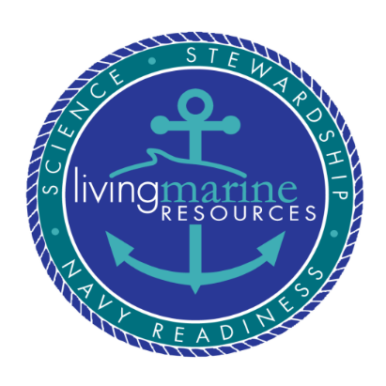
90 Upper College Road, Kingston, RI
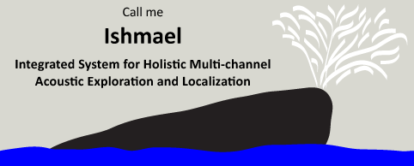

www.bioacoustics.us/ishmael

