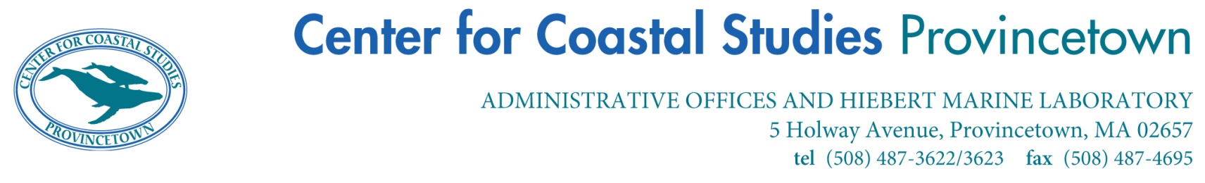

Summer 2024 Internship Opportunity

The Center for Coastal Studies is a non-profit organization dedicated to conducting scientific research with emphasis on marine mammals of the western North Atlantic and on the coastal and marine habitats and resources of the Gulf of Maine. CCS has been conducting research and marine and coastal educational programs on Cape Cod for 46 years.
Education Responsibilities-Intern/s will assist with environmental education programs, including on-site programs, off-site programs, and festivals, including CCS’s signature summer week of events: Whale Week: A Celebration of the Sea, and Whale Camp. Interns will assist in staffing the Center’s SEASpace Marine Discovery Center, and beach pop-up tents; designing and delivering presentations, answering questions about CCS, marine animals (especially whales, seals and sharks) and ocean conservation issues, and other general duties.
Interns must have their own transportation. Housing is not provided, but the Center will assist candidates in finding potential housing. A small stipend is provided.
Qualifications-
- The internship is open to students who are currently enrolled in, or recently graduated from an accredited college or university.
- Preference will be given to students or recent graduates working towards environmental studies, education, marine science, biology or other related fields.
- Intern should demonstrate strong written and verbal communication skills.
- Intern should be a self-starter able to take responsibility for completing projects.
- Students that are adaptable, responsible, hard working, willing to learn, and have attention to detail are encouraged to apply.
- Must be able to work independently and as part of a team.
- Must be comfortable working with all ages.
- Must be comfortable working outside in all conditions.
- Must be comfortable working with and handling marine species.
- Must be able to carry at least 30lbs over short distances.
- Interns must be able to commit to at least two-three months; preferred start date-end date mid June to mid August, but dates are flexible based on school schedules.
- Interns must work a minimum of 20 hours per week.
- Schedule is flexible but intern may have to work some weekends and evenings.
- Preference will be given to students with secured housing on Cape Cod.

To Apply- Send your resume, cover letter, and one letter of reference to Valerie Daniels at employment@coastalstudies.org or 5 Holway Ave, Provincetown, Massachusetts 02567. Applications must be received by March 8, 2024.

