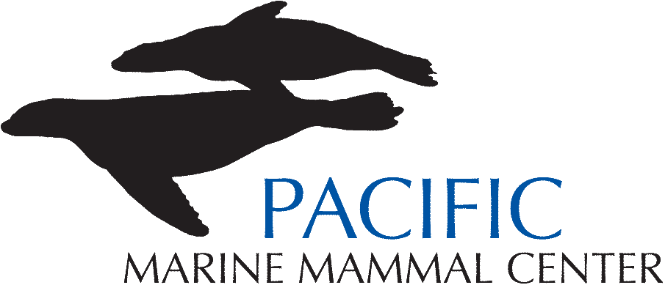

The Pacific Marine Mammal Center, an equal opportunity, non-profit employer, is seeking candidates for a part-time (20 hr/wk) position of Assistant Staff Veterinarian reporting to the Medical Director.
The Assistant Veterinarian is responsible for the clinical care of marine mammals in rehabilitation; the candidate’s primary focus will be clinical practices, secondary focus on the pathology of the marine mammals at the center. The successful candidate will also educate and inform Animal Care Personal on new information, protocols and procedures, cross train animal care personal in the use of medical equipment, assist in the development of externship program to provide externships to veterinary students and residents and collaborate and coordinate research projects, and present case reviews/diagnostic reviews at peer reviewed conferences. In addition to clinical care, the staff veterinarian must have the knowledge, interest and ability to collaborate effectively with researchers, education and other staff members.
To learn more about the Pacific Marine Mammal Center: http://pacificmmc.org/
Requires: 5 yrs experience in clinical marine mammal veterinary medicine/wildlife or zoo medicine or equivalent; knowledge of current marine mammal health and disease issues demonstrated through publication and presentation record, a doctorate in veterinary medicine (DVM) or equivalent and a higher degree (masters, doctorate, or board certification; and must be eligible for a California state license to practice veterinary medicine. This is a career position and has the potential to develop into a full time position after 2 years.
- Final candidate subject to background check. ♦
Salary will be based on education and experience, to apply: email resume and salary requirements to: Lorraine Reafsnyder at lorraine@hradvisors.com.

